BASIC SELECT
Query all columns for all American cities in the CITY table with populations larger than 100000. The CountryCode for America is USA.
The CITY table is described as follows:
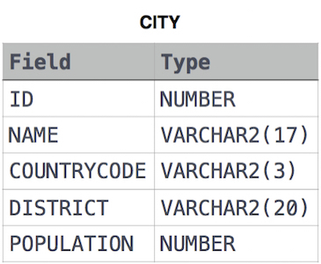
select * from city where population>100000 and countrycode='usa'
Query the NAME field for all American cities in the CITY table with populations larger than 120000. The CountryCode for America is USA.
The CITY table is described as follows:
select name from city where population>120000 and countrycode='usa'

Query all columns (attributes) for every row in the CITY table.
The CITY table is described as follows:
select * from city
Query all columns for a city in CITY with the ID 1661.
The CITY table is described as follows:
select * from city where id=1661

Query all attributes of every Japanese city in the CITY table. The COUNTRYCODE for Japan is JPN.
The CITY table is described as follows:
select * from city where countrycode='jpn'
Query the names of all the Japanese cities in the CITY table. The COUNTRYCODE for Japan is JPN.
The CITY table is described as follows:
select name from city where countrycode='jpn'
Query a list of CITY and STATE from the STATION table.
The STATION table is described as follows:
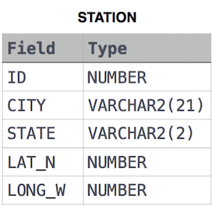
where LAT_N is the northern latitude and LONG_W is the western longitude.
select city,state from station
Query a list of CITY names from STATION for cities that have an even ID number. Print the results in any order, but exclude duplicates from the answer.
The STATION table is described as follows:
where LAT_N is the northern latitude and LONG_W is the western longitude.
select distinct city from station where mod(id,2)=0

Find the difference between the total number of CITY entries in the table and the number of distinct CITY entries in the table.
The STATION table is described as follows:
where LAT_N is the northern latitude and LONG_W is the western longitude.
For example, if there are three records in the table with CITY values 'New York', 'New York', 'Bengalaru', there are 2 different city names: 'New York' and 'Bengalaru'.
select count(city)-count(distinct city) from station
Query the two cities in STATION with the shortest and longest CITY names, as well as their respective lengths (i.e.: number of characters in the name). If there is more than one smallest or largest city, choose the one that comes first when ordered alphabetically.
The STATION table is described as follows:
where LAT_N is the northern latitude and LONG_W is the western longitude.
Sample Input
For example, CITY has four entries: DEF, ABC, PQRS and WXY.
Sample Output
ABC 3
PQRS 4
Explanation
When ordered alphabetically, the CITY names are listed as ABC, DEF, PQRS, and WXY, with lengths and . The longest name is PQRS, but there are options for shortest named city. Choose ABC, because it comes first alphabetically.

(select city,length(city) from station
order by length(city) asc,city asc limit 1)
union
(select city,length(city) from station
order by length(city) desc,city asc limit 1)

Query the list of CITY names starting with vowels (i.e., a, e, i, o, or u) from STATION. Your result cannot contain duplicates.
Input Format
The STATION table is described as follows:
where LAT_N is the northern latitude and LONG_W is the western longitude.
select city from station where substring(city,1,1) in('a','i','o','e','u')
Query the list of CITY names ending with vowels (a, e, i, o, u) from STATION. Your result cannot contain duplicates.
Input Format
The STATION table is described as follows:
where LAT_N is the northern latitude and LONG_W is the western longitude.
select distinct city from station where right(city,1) in('a','i','o','e','u')
Query the list of CITY names from STATION which have vowels (i.e., a, e, i, o, and u) as both their first and last characters. Your result cannot contain duplicates.
Input Format
The STATION table is described as follows:
where LAT_N is the northern latitude and LONG_W is the western longitude.
select distinct city from station where substring(city,1,1) in('a','i','o','e','u') and right(city,1) in('a','i','o','e','u')
Query the list of CITY names from STATION that do not start with vowels. Your result cannot contain duplicates.
Input Format
The STATION table is described as follows:
where LAT_N is the northern latitude and LONG_W is the western longitude.
select distinct city from station where substring(city,1,1) not in('a','i','o','e','u')

Query the list of CITY names from STATION that do not end with vowels. Your result cannot contain duplicates.
Input Format
The STATION table is described as follows:
where LAT_N is the northern latitude and LONG_W is the western longitude.
select distinct city from station where right(city,1) not in('a','i','o','e','u')
Query the list of CITY names from STATION that either do not start with vowels or do not end with vowels. Your result cannot contain duplicates.
Input Format
The STATION table is described as follows:
where LAT_N is the northern latitude and LONG_W is the western longitude.
select distinct city from station where substring(city,1,1) not in('a','i','o','e','u') or right(city,1) not in('a','i','o','e','u')
Query the list of CITY names from STATION that do not start with vowels and do not end with vowels. Your result cannot contain duplicates.
Input Format
The STATION table is described as follows:
where LAT_N is the northern latitude and LONG_W is the western longitude.
select distinct city from station where substring(city,1,1) not in('a','i','o','e','u') and right(city,1) not in('a','i','o','e','u')

Query the Name of any student in STUDENTS who scored higher than Marks. Order your output by the last three characters of each name. If two or more students both have names ending in the same last three characters (i.e.: Bobby, Robby, etc.), secondary sort them by ascending ID.
Input Format
The STUDENTS table is described as follows: 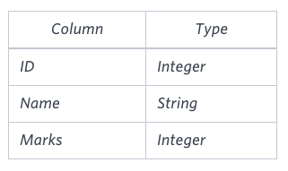 The Name column only contains uppercase (A-Z) and lowercase (a-z) letters.
select name from students where marks>75 order by right(name,3), id asc

Write a query that prints a list of employee names (i.e.: the name attribute) from the Employee table in alphabetical order.
Input Format
The Employee table containing employee data for a company is described as follows:
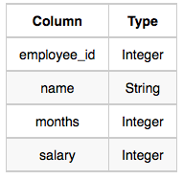
where employee_id is an employee's ID number, name is their name, months is the total number of months they've been working for the company, and salary is their monthly salary.
select name from employee order by name asc

Write a query that prints a list of employee names (i.e.: the name attribute) for employees in Employee having a salary greater than per month who have been employees for less than months. Sort your result by ascending employee_id.
Input Format
The Employee table containing employee data for a company is described as follows:
where employee_id is an employee's ID number, name is their name, months is the total number of months they've been working for the company, and salary is the their monthly salary.
select name from employee where salary>2000 and months<10 order by employee_id asc

